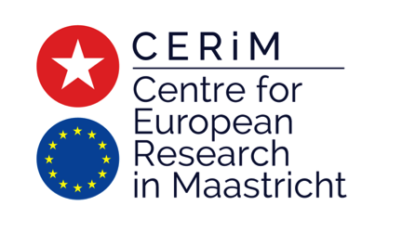

Workshop

Recalibrating executive-legislative relations in the European Union

UM Campus Brussels
18-19 January 2018

Organizers: Diane Fromage, Thomas Christiansen, Anna Herranz-Surrallés

18 January 2018

13:30 – 13:45: Opening address
Thomas Christiansen and Diane Fromage (Maastricht University)

13:45 – 15:00: Panel 1: Executive-legislative relations in the European integration process
Chair: Diane Fromage (Maastricht University)

Peter Bursens (Antwerp University) - The EU’s multilevel parliamentary system: escaping from the trilemma of market integration, national democracy and national sovereignty
Claudia Wiesner (Hamburg University) - Representative Democracy in Times of Austerity: New Challenges in the EU Multi-level System

Discussant: Mendeltje van Keulen (Tweede Kamer)

15:00 – 15:30: Coffee break

15:30 – 17:30: Panel 2: Recalibration of executive-legislative relations at EU level
Chair: Christine Neuhold (Maastricht University)

Eugénia da Conceição-Heldt (Technical University of Munich) - A Cacophony of Voices? Preference Cohesiveness of Multiple Principals and the Commission's Discretion in Trade Negotiations
Elena Griglio (LUISS Guido Carli University) - The divided accountability of the European Council and the Council: solving the puzzle through collective parliamentary oversight
Marco Urban (University of Lausanne) - Interinstitutional Agreements’ influence on the competences of the EP in the procedure for negotiating and concluding International Agreements
Wolfgang Weiß (Speyer University) - The European Parliament’s Role in the Operation of Trade Agreements

Discussant: Thomas Fich (European Commission)

Dinner (for speakers and discussants only)

19 January 2018

9:00 – 10:00: Panel 3: Recalibration of executive-legislative relations at Member State level
Chair: Thomas Christiansen (Maastricht University)

Diane Fromage (Maastricht University) - Transposition and implementation of EU law and the provoked shift in the balance of powers at national level
Jan Grinc (Charles University) & Robert Zbíral (Masaryk University) - De-parliamentarisation thesis and national strategies of EU law implementation: Does the executive/legislative divide matter?

Discussant: Tim de Bondt (Belgian Senate)

10:00 – 10:30: Coffee break

10:30 – 12:30: Panel 4: Recalibrating the Multi-level parliamentary field
Chair: Anna Herranz-Surrallés (Maastricht University)

Cristina Fasone (LUISS Guido Carli University) & Maria Romaniello (IMT Lucca & LUISS Guido Carli University) - National and regional parliaments on EU trade agreements: democratic facilitators or veto players?
Péter Márton (Central European University) - In pursuit of democratic input legitimacy in EU trade agreements: The role of European Parliaments
Katharina Meissner (University of Vienna) & Rosen Guri (University of Oslo) - Exploring interaction between national parliaments and the European Parliament in EU external affairs
Charikleia Vlachou (Université d’Orléans) - Democratic accountability of European agencies: is there a role for national parliaments?

Discussant: Pekka Nurminen (European Parliament)

12:30 – 12:45: Concluding remarks and next steps
Anna Herranz-Surrallés (Maastricht University)

